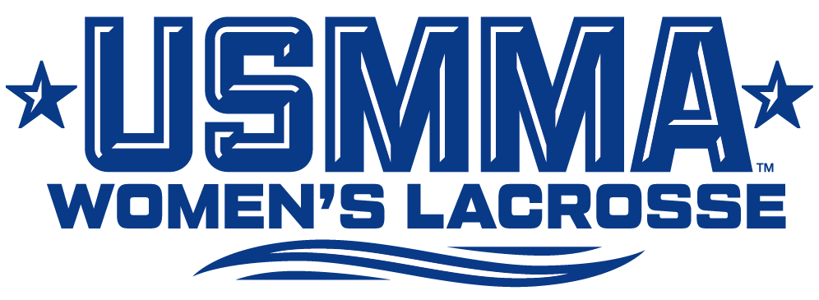
2026 USMMA Women’s Lacrosse Roster

No. Name Yr. Pos. Ht. Hometown/High School
2 Isabella Judeh So. D 5-10 Orland Park, Ill./Mother McAuley
3 Isabelle Perry Fr. A 5-8 Atlanta, Ga./Midtown
5 Ainsley Carlon Jr. A 5-3 Gilbert, Ariz./Basha
6 Keira Collins Sr. D 5-2 Sayville, N.Y./Sayville
7 Ava Booker Fr. G 5-6 Tampa, Fla./Robinson
10 Nicole Nagengast Sr. D 5-7 Seaford, N.Y./Kellenberg Memorial
11 Lana Hayes So. M 5-10 Toms River, N.J./Toms River North
13 Amber Fields So. A 5-7 St. Augustine, Fla./Nease
14 Leslie Wysong Jr. M 5-5 Mount Pleasant, S.C./Bishop England
17 Grace Moriarty So. D 5-6 Groton, Conn./Fitch
18 Juliet Trouse So. D 5-10 Riverdale, N.J./Pompton Lakes
19 Reese Ripley So. M 5-6 Denver, Colo./Denver North
20 Karianna Eagle Sr. G 5-4 Little Egg Harbor Township, N.J./Pinelands Regional
21 Lauren Mavity Fr. M 5-8 Navarre, Fla./Navarre
22 Grace Picozzi Jr. M 5-11 Collegeville, Pa./Lansdale Catholic
23 Sarah Litz Fr. M 5-7 Westminster, Md./Mount De Sales Academy
24 Meghan Shippos So. D 5-9 Bow, N.H./Brewster Academy
25 Dylan Schnelle Fr. D 5-4 Jamestown, R.I./North Kingstown

Coaching Staff
Head Coach: Kyle Simensky (Cortland '08) – 14th Season
Assistant Coach: Maegan Meritz (Stony Brook '16) – 10th Season
Team Captains: #10 Nicole Nagengast, #20 Karianna Eagle, #22 Grace Picozzi

Pronunciations (Emphasis goes on the on BOLD CAPS syllable)
#2 – JUDE-uh
#5 – Car-LOAN
#6 – KEER-uh
#10 – NAG-in-gast
#11 – First name rhymes with “banana”
#14 – WEISS-ong
#17 – More-ee-ARE-dee
#18 – Last name rhymes with “house”
#20 – CARRY-ah-na
#22 – Pick-COE-zee
#23 – Jab-lo-NOW-ski
#24 – last syllable is like “post” without the t
#25 – Shin-EL

